SUMMARY OF ROBERTSON’S SALIENT
MISTAKES
Gary L. Aguilar, MD
Doug DeSalles, MD
Bill Simpich, JD

Randy Robertson’s review of Josiah Thompson’s new book, Last Second in Dallas, was
recently posted at Jim DiEugenio’s Kennedys and King website. It contains numerous errors.
This paper will address five of those mistakes.

Robertson claims that dark threads were carried into Connally’s wrist wound by the fragment that struck his wrist. He finds this significant, claiming this could not have happened when Thompson thinks it happened (at frame 328). Robertson’s citation of a photo of Connally’s white shirt French cuff showing a bullet-caused slit confirms Thompson’s finding.

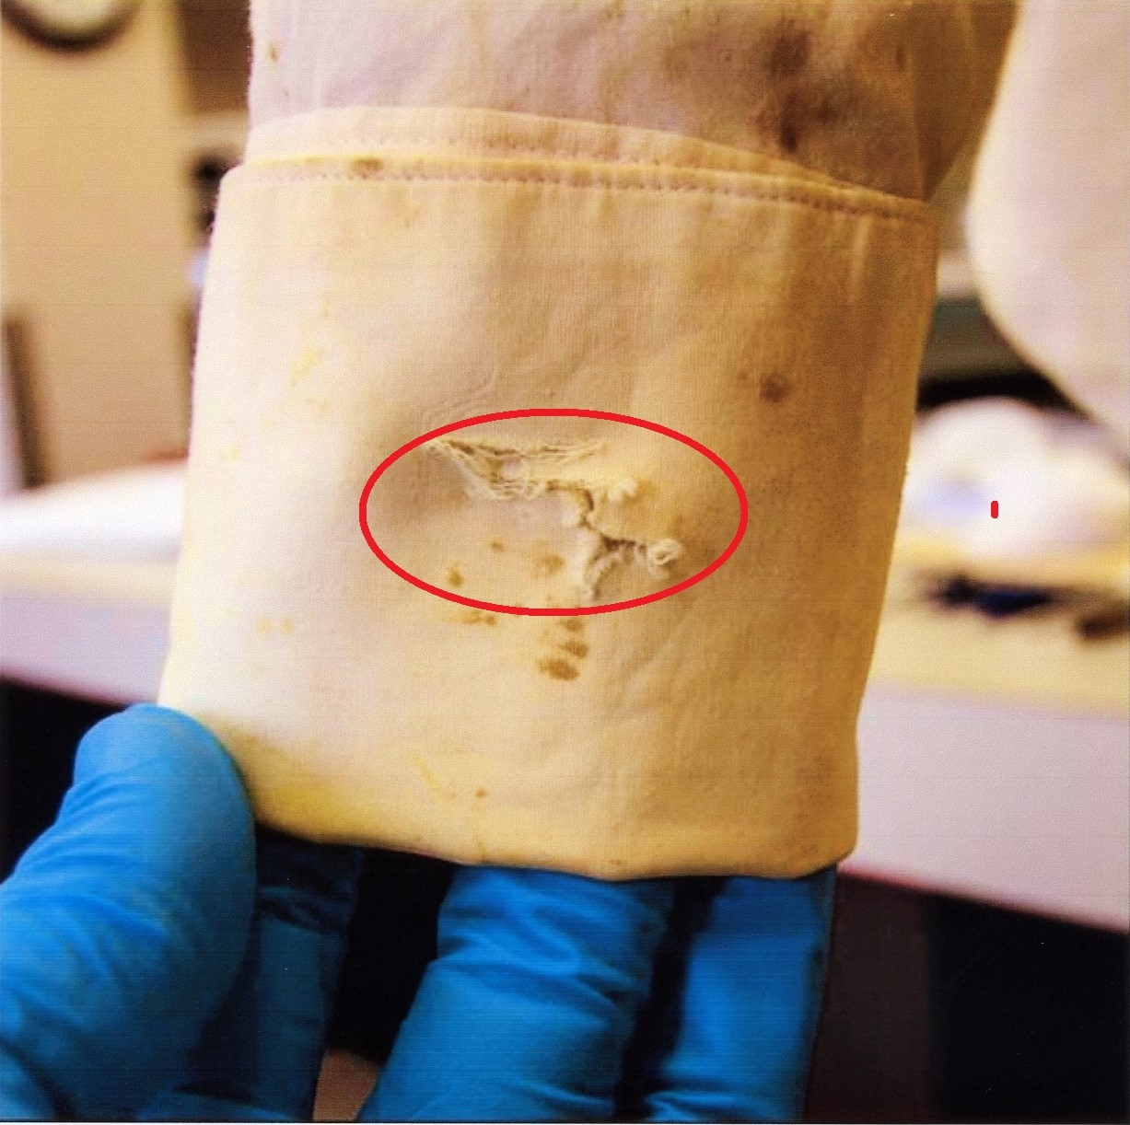
Figure 1 Exit slit in right cuff of Connally’s shirt reproduced by Robertson in his review.

According to Connally’s wrist surgeon, he suffered “a perforating wound” on the back or dorsal side of his wrist “approximately 5 centimeters above the wrist joint.” This was the entry wound.

The “second wound of exit” was on the other or palmar side of the wrist “about 2 centimeters, something less that 1 inch, above the wrist crease.”

Dr. Gregory was certain the wound was caused by a sharp-sided, irregular fragment because it carried fabric from Connally’s jacket into the wound.

The fragment that struck Connally’s wrist came out on the other side of the wrist—the palmar side—about 3 centimeters closer to the wrist crease. [All quotes from Dr. Gregory, 4H128.]

Robertson shows a photo drawn from "Details of Governor Connally's Damaged Clothing" showing a slit in the middle of the white cuff of Connally's shirt.
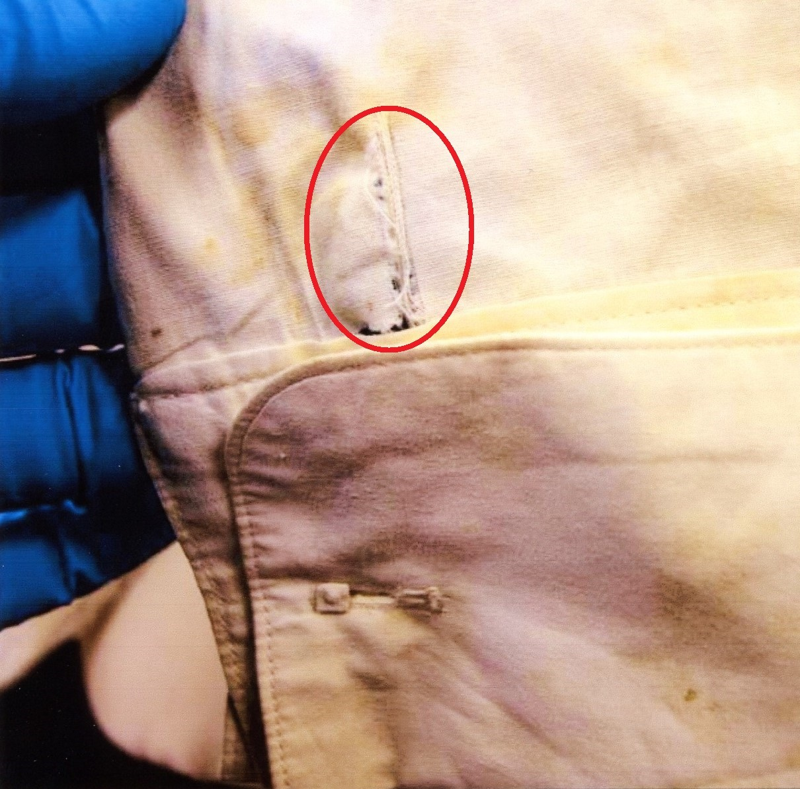
Robertson’s source for his photo is unchallengeable. It is a photographic presentation of the bullet holes in Connally’s clothing called “Details of Governor Connally’s Damaged Clothing” published by the Texas State Library and Archives Commission. Robertson’s photo comprises page 6 of this study. Had he simply turned to the page before he would have encountered the photo below (Figure 2) from page 5 of the study. Two pages further along, Robertson would have encountered the second photo shown below (Figure 3) that came from page 8 of the study.

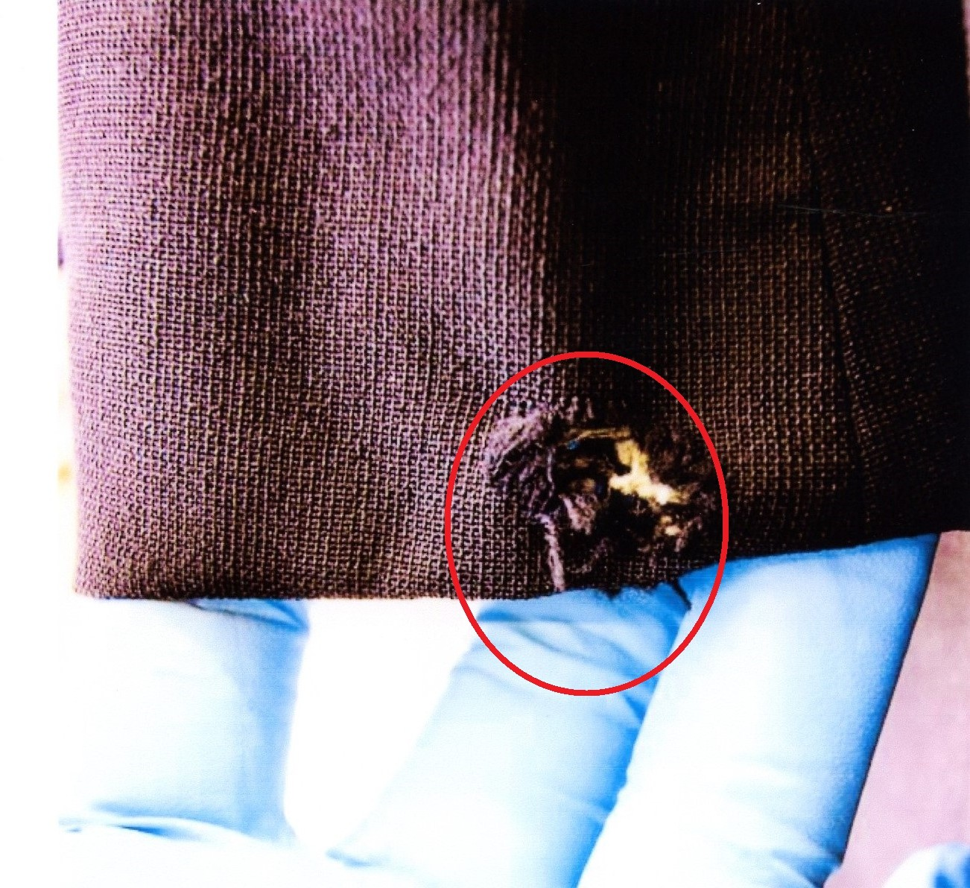

Figure 2 Entry slit above right cuff of
shirt.
Figure 3 Entry hole at bottom of Connally right coat sleeve which lay over slit above cuff in photo immediately to left.

Robertson’s problem is simple. He picked the wrong picture.
It is elementary in assassination studies that Connally was struck above the right wrist in the right forearm. The bullet fragment hit bone and did considerable damage before exiting on the opposite side of his wrist a couple of inches closer to the wrist crease. This is exactly what the damage to the clothes and the testimony of Connally’s wrist surgeon tells us.
Robertson showed the photo of the white shirt’s French cuff that pictured the slit where the bullet exited the wrist. There is another photo showing a slit where the bullet entered the wrist at a point just above the white cuff's seam. This slit matches up exactly with a small hole within a quarter-inch of the bottom of Connally's suit coat.
It isn’t just that Robertson failed to undermine Thompson’s claim. No, his error was not just a minor WHOOPS! Because now we can see that the hole at the bottom of the right jacket sleeve, the entry slit in the shirt above the cuff, and the entry wound in the forearm all match a particular moment in time.
That moment is frame 328, the very moment Last Second in Dallas says the fragment hit Connally’s right wrist, the very moment Robertson was trying to prove could not be when it happened. Instead of undermining Thompson’s scenario, Robertson confirmed it. See illustrations below:

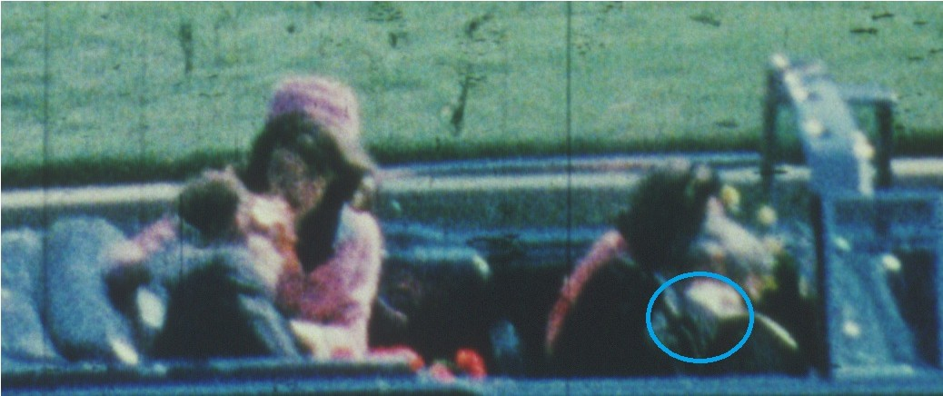

Figure 4 Cyan circle shows end of coat sleeve and white shirt cuff in

Z frame 328.

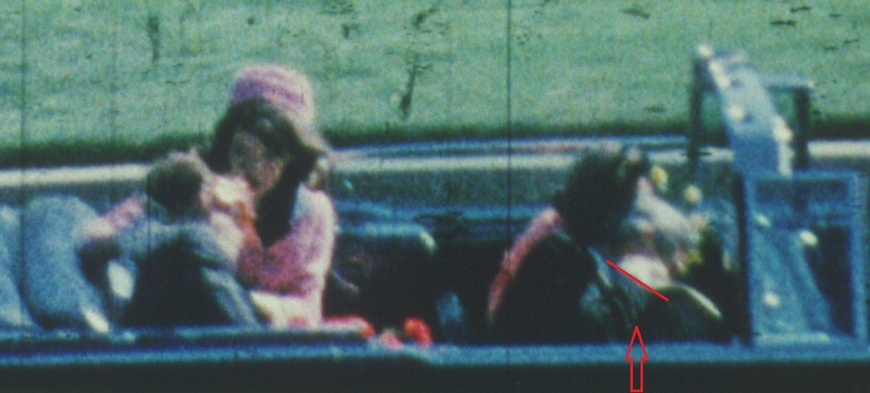
Figure 5 Red arrow and diagonal red line show bottom of right arm of Connally dark coat in Z frame 328.

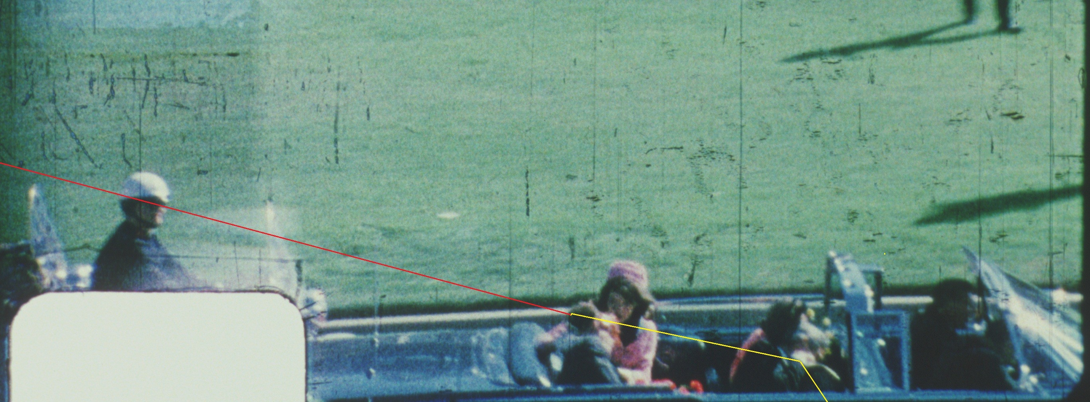
Figure 6 Frame 328 with trajectories of bullet and Connally fragment.

- Support for the finding of a fragment from a rear-fired shot to Kennedy’s head at frame 328 is a sun flare in Zapruder’s camera shown in the middle of the windshield at frames 329, 330 and 331. Such a sun flare is consistent with a metal fragment from the 328 impact striking the middle of the windshield, bowing it out and causing the sun flare. Robertson’s challenge is based on a reflection seen at frame 314, which is merely a reflection off the chrome strip on a vent window.

First, the sun flare as it occurs in frames 329, 330 and 331:

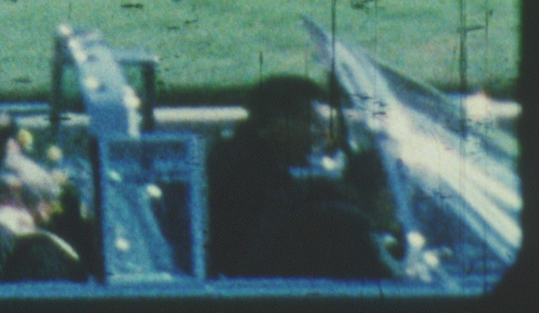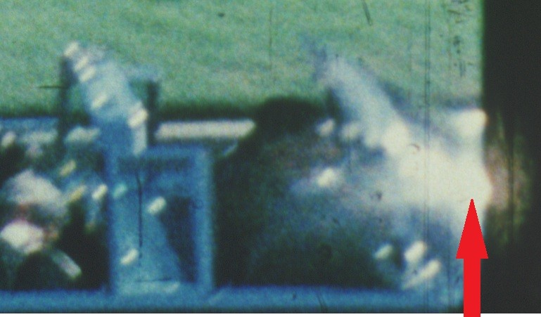

Figure 7 Frame 328. No discernible flare is visible.
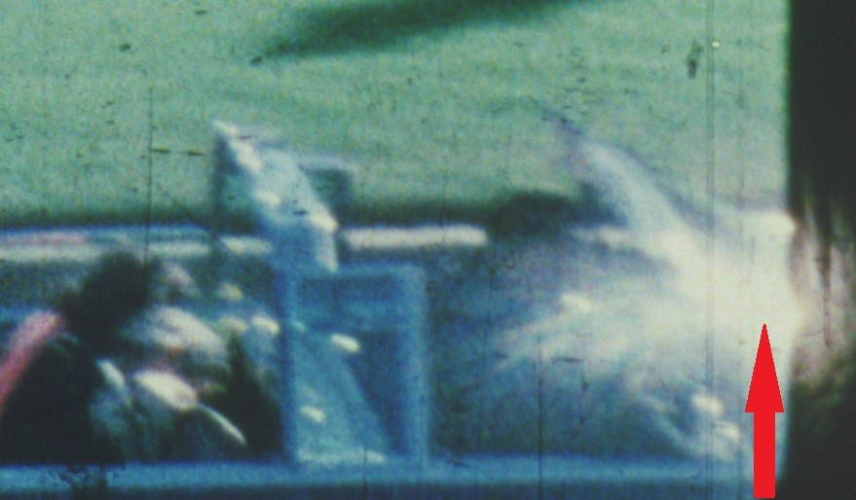
Figure 9 Frame 330 flare expanding somewhere in middle of windshield.
Figure 8 Frame 329 flare visible and growing somewhere in middle of wind-
shield.

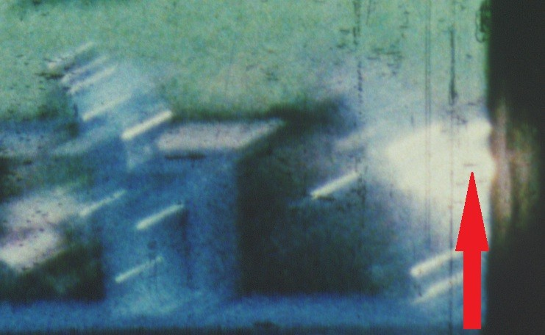
Figure 10 Frame 331 robust flare now smeared by camera movement

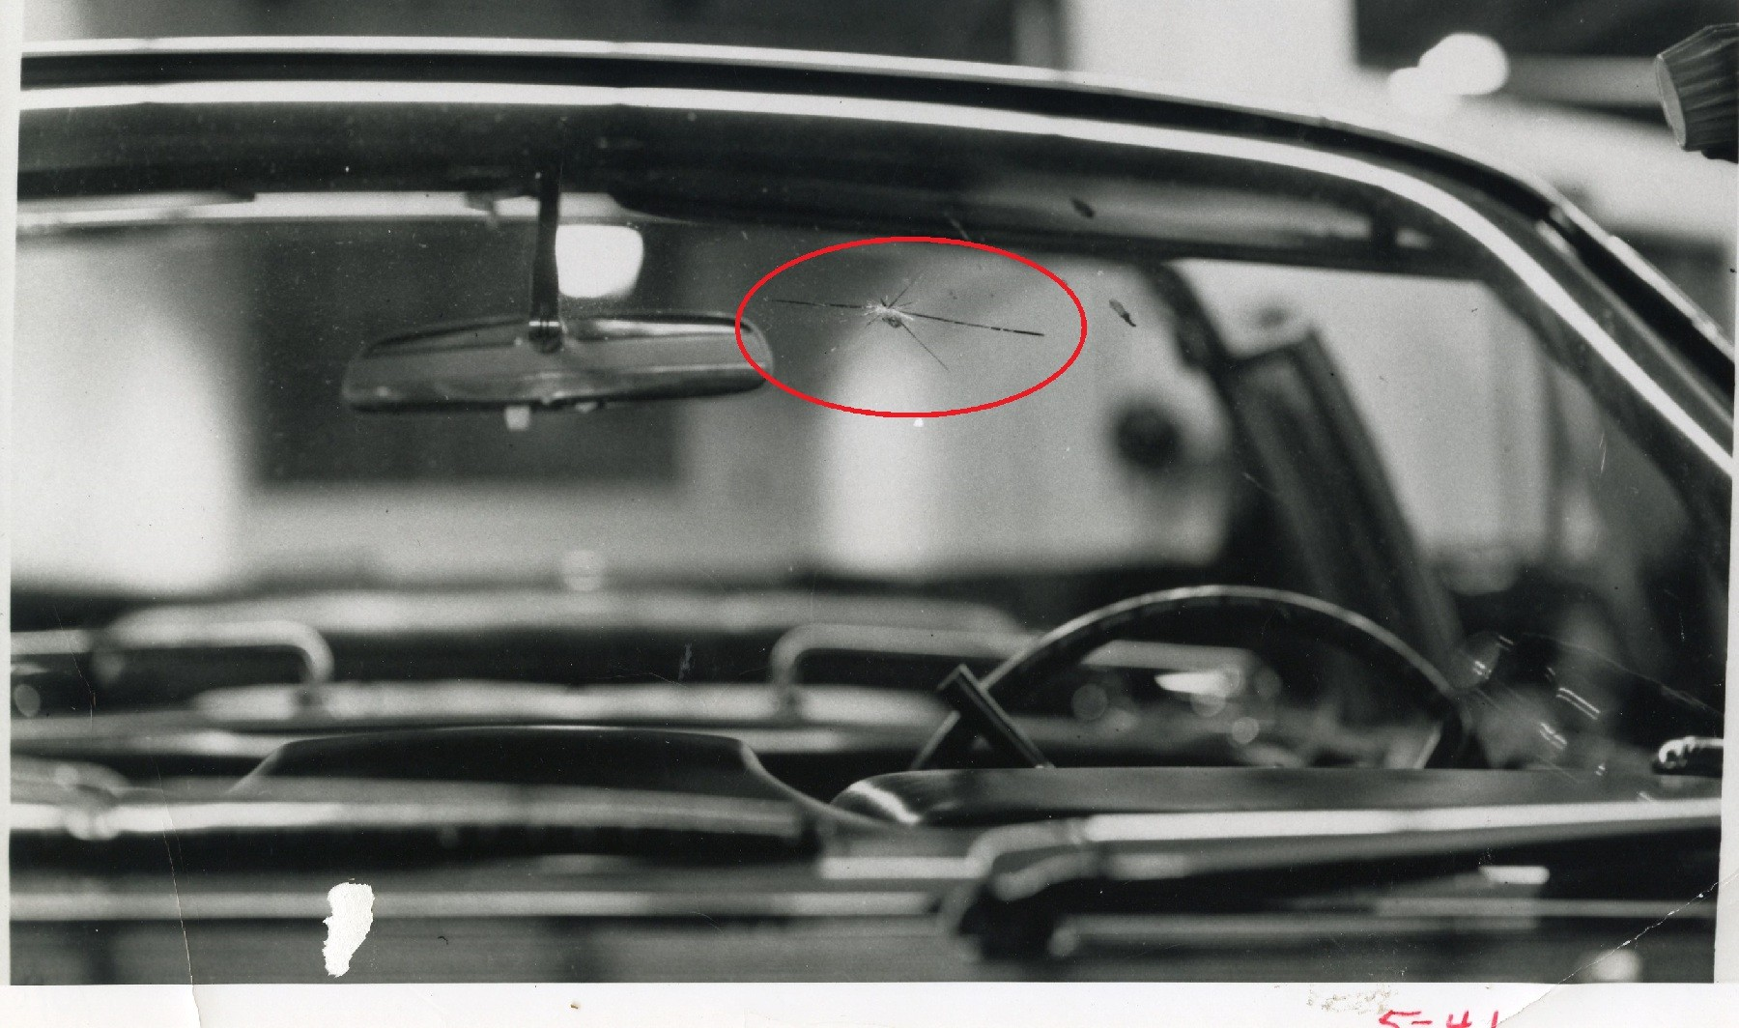
Figure 11 CE 350

In the early morning hours of November 23rd, FBI Agent Robert Frazier carried out a forensic examination of the limousine. He found an impact point on the interior surface of the windshield as shown in the photo at left. It was characterized by Frazier as showing both a lead smear and a crack in the rear-facing surface of the glass. During his examination, Frazier was

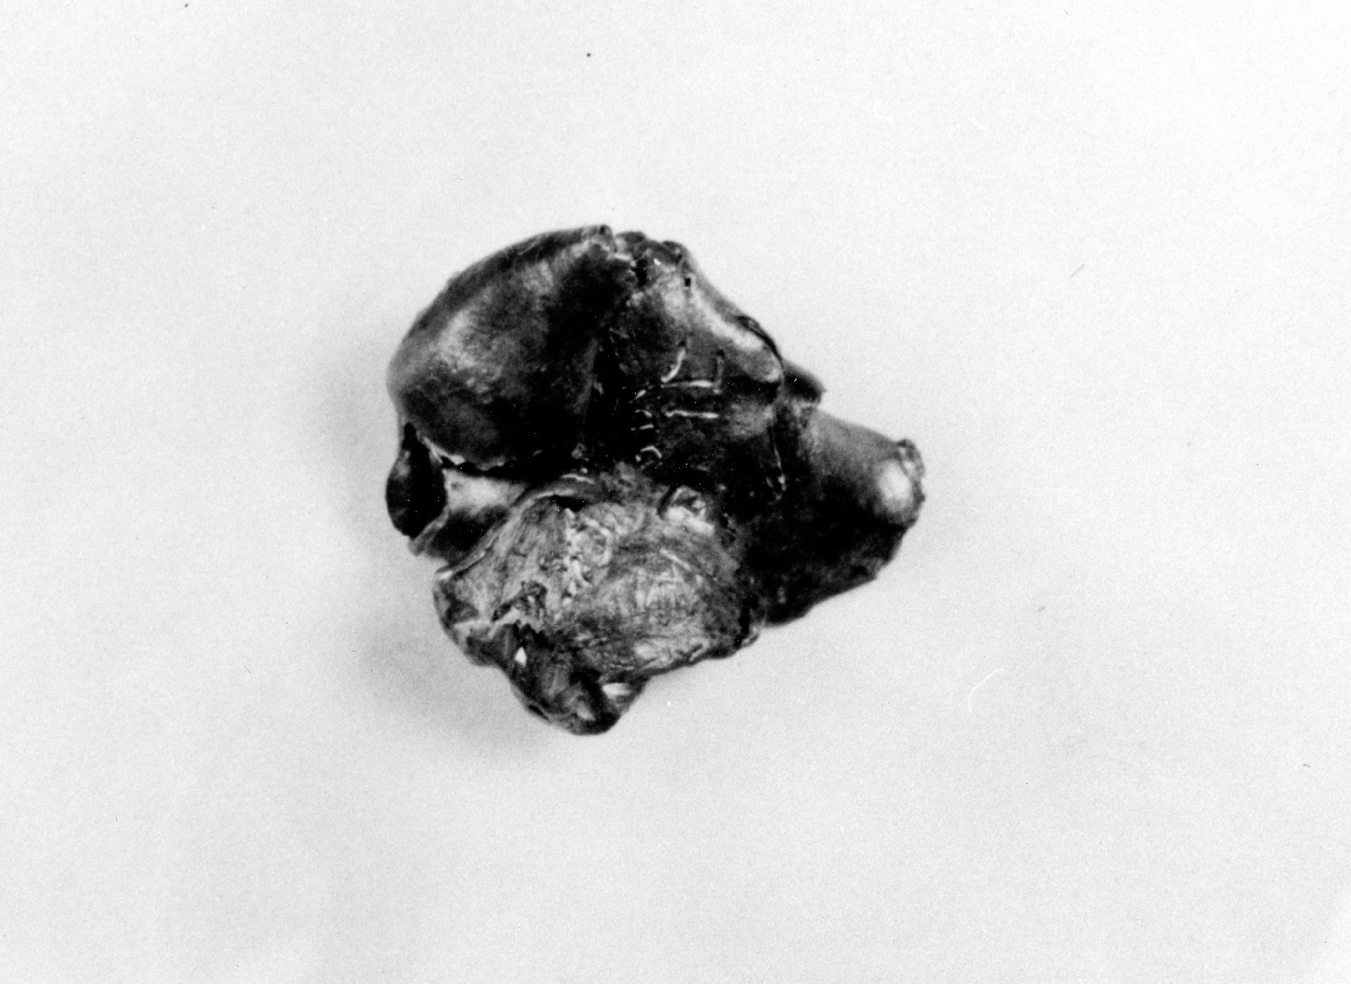

Figure 12 CE 567
led to two large fragments found earlier by Secret Service agents in the front seat area of the limousine. They were subsequently found to have been fired from Oswald’s rifle. One—Commission Exhibit 567—appears to be made up largely of exposed lead. These items of evidence establish a likely narrative: A bullet from the alleged Oswald rifle strikes the back of the President’s head, sending fragments into John Connally’s right wrist, CE 567 into the windshield where it left a left a lead smear and caused a windshield flare, and finally a final fragment striking a rear-facing chrome strip above the windshield.

Robertson claims that he has discovered a similar windshield flare just after frame 313 and offers a reproduction of frame 314 to make his case. But let’s look closely at the frames that come before and after frame 314:
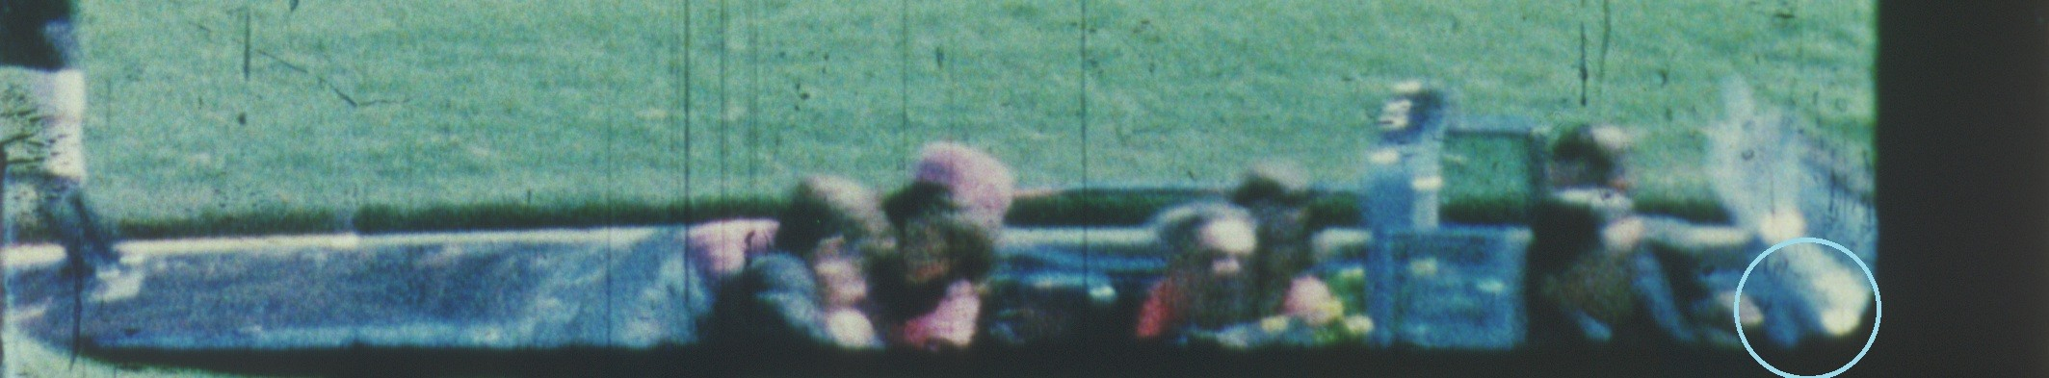

Figure 13 Frame 309
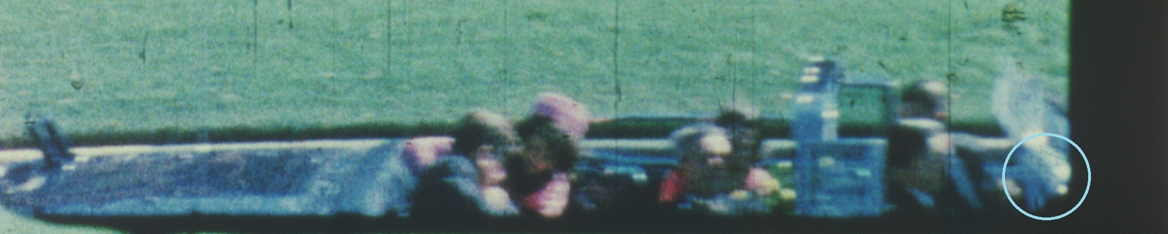
Figure 14 Frame 310
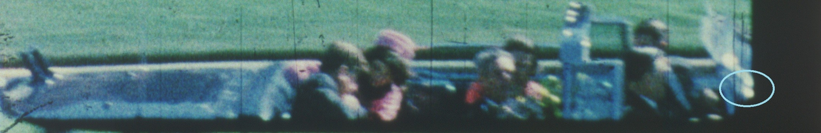
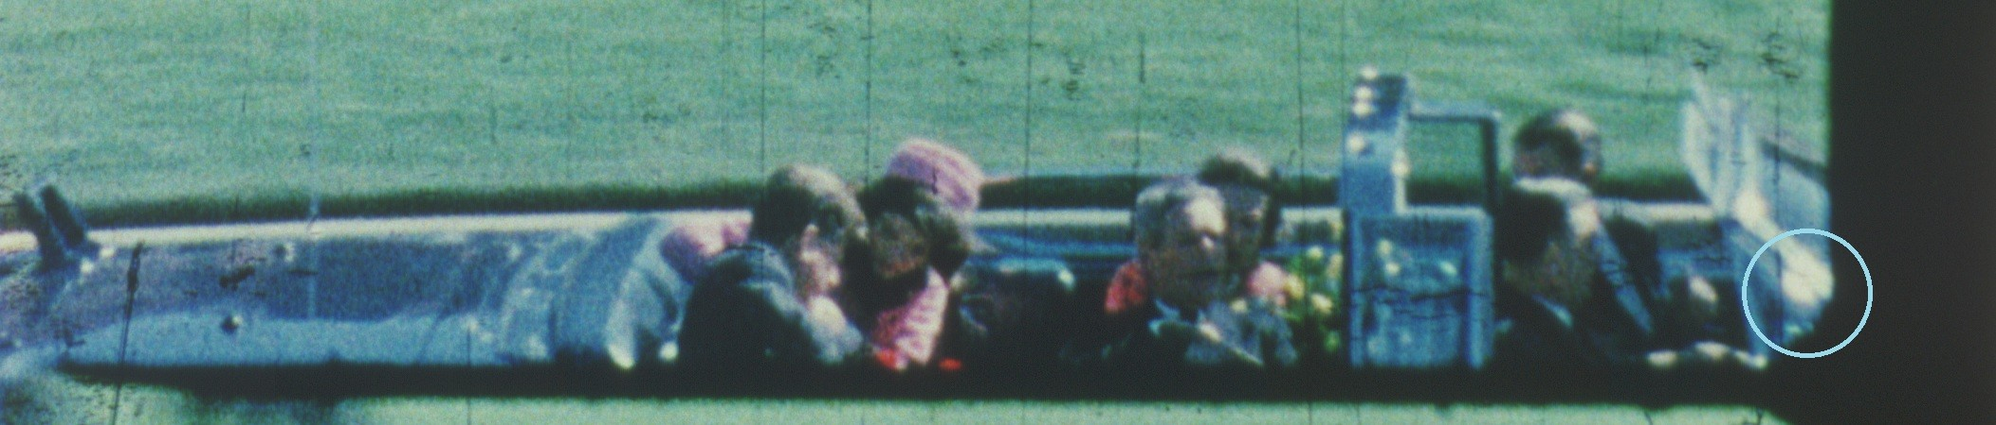
Figure 15 Frame 311

Figure 16 Frame 312

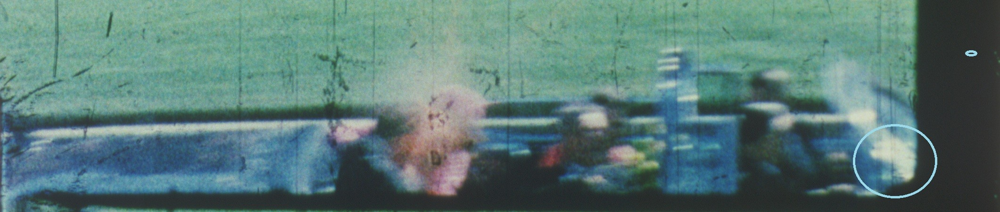
Figure 17 Frame 313

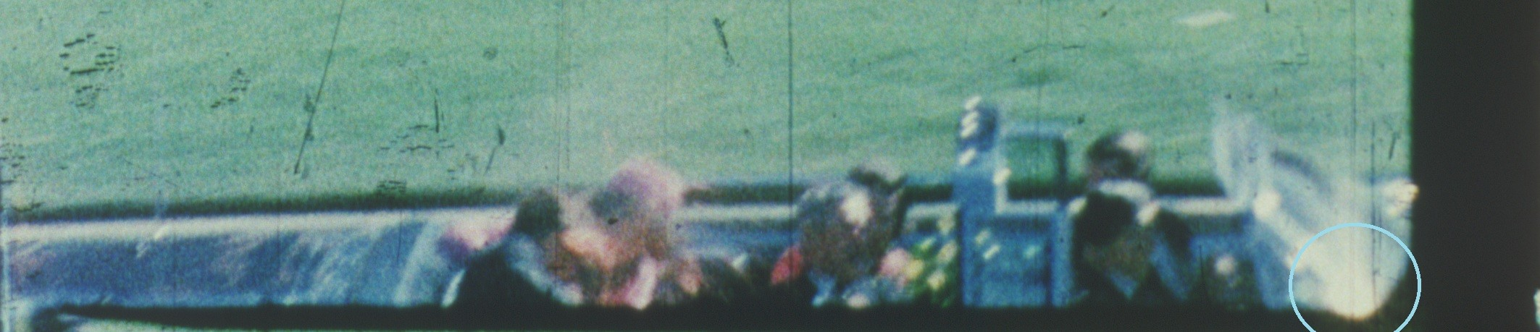
Figure 18 Frame 314

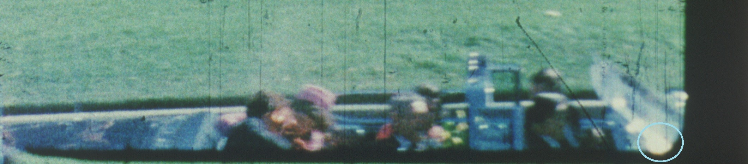
Figure 19 Frame 315
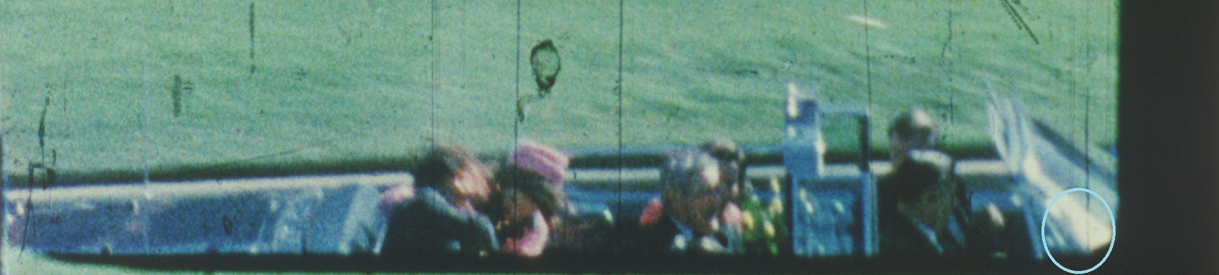
Figure 20 Frame 316
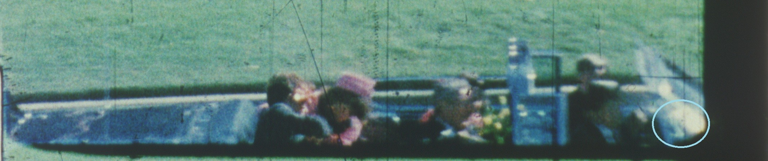
Figure 21 Frame 317

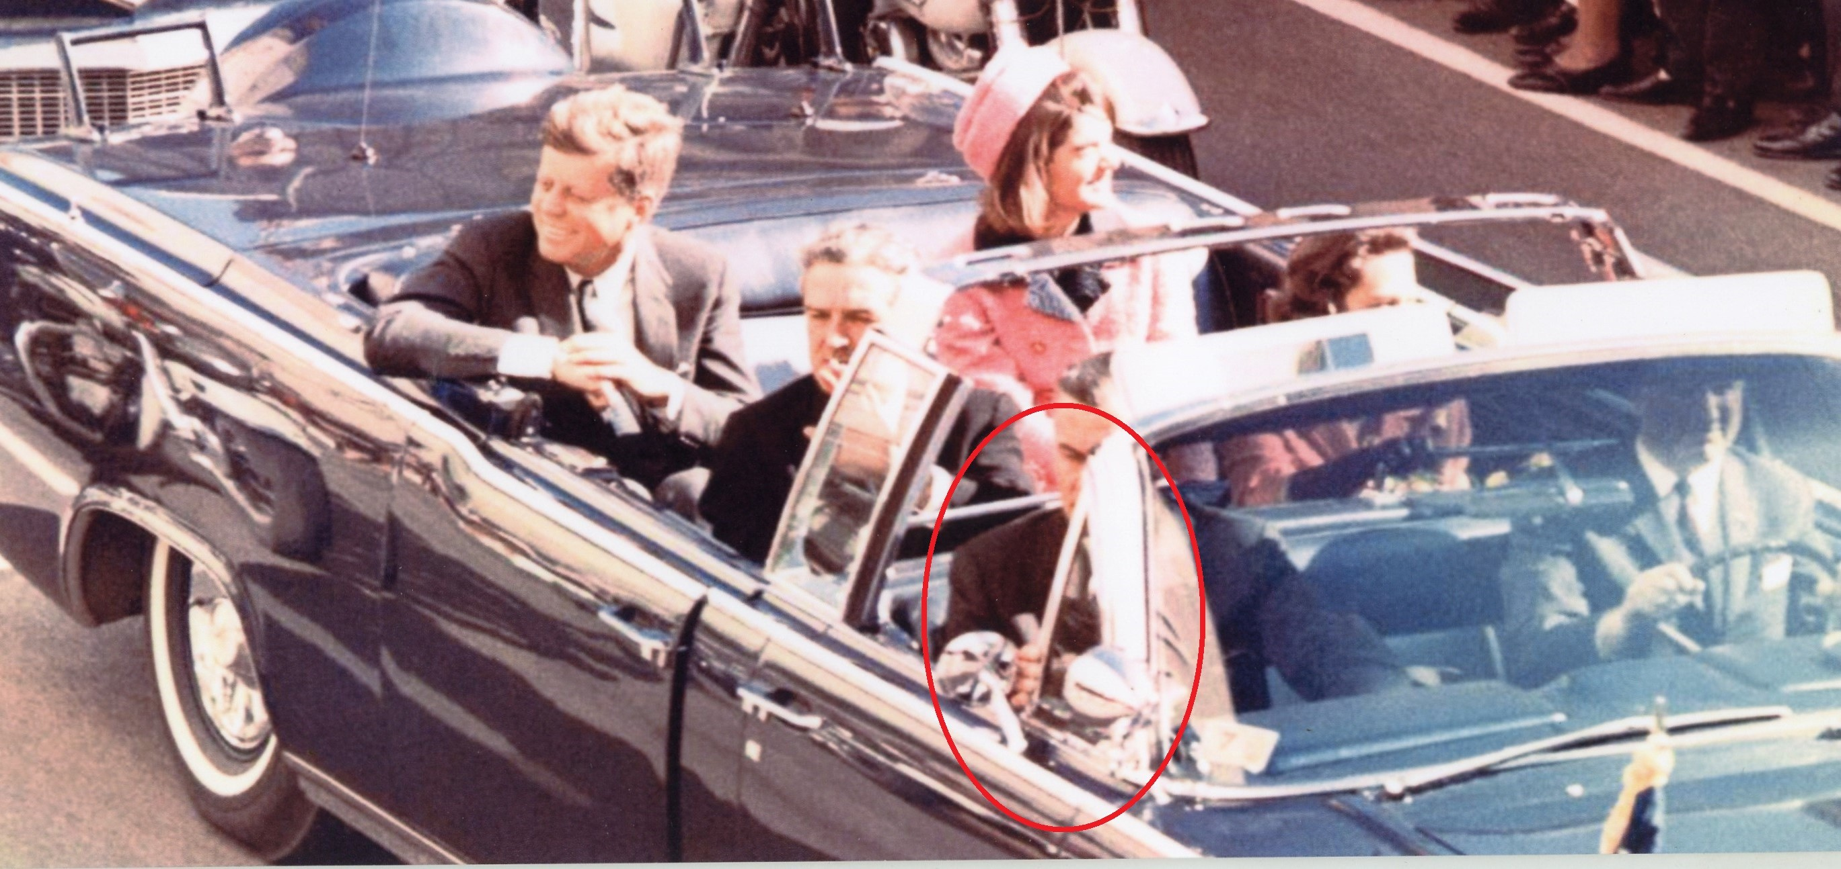

Figure 22 Limousine on Main Street. Note chrome strip on leading edge of vent window (red oval) obscuring Agent Kellerman’s face.

If we concentrate on the part of the limousine where Robertson claimed he found his “flare,” we find something extremely interesting. This is the location of the passenger side vent window, a chrome strip covering a side support for the windshield and several mirrors or other chrome objects.

Robertson’s “flare” appears to be a reflection off the chrome strip covering the leading edge of the vent window that obscures most of Agent Kellerman’s face in the above photo.

If we now turn to the sequence of Zapruder frames we can see that this chrome strip and associated chrome fixtures are reflecting sunlight as early as frame 309. Starting with frame 313 and the presence of the blur effect, these reflections smear and look larger.

But both before and after frame 313 the reflections are restricted to the frame of the vent window, the chrome strip along its leading edge that covers the windshield support, and other chrome objects near it.

These surfaces reflect brightness into the camera lens before frame 313, and, what Robertson calls a “flare,” never spreads beyond them. Robertson would have us think that he has discovered a “flare” like the one at frames 329-331, but the reflection he points to never touches the windshield and appears long before any shot was fired.

In his May 3, 2020 exchange with Art Snyder, Robertson claims “you also have to take into account the flare of reflected light at 314 and Connally’s forward wrist motion after 313.” Is he claiming that Connally’s right wrist is hit by a fragment at 313 and driven forward in the limousine, or is he claiming that the wrist and its containing French cuff were driven forward “out of the jacket sleeve” by such a fragment hit at 313? Either way, frames 312-323 show Connally holding his Stetson close to his chest, with no movement.

Like with the “flare at 314”, the frames from 312-323 refute Robertson’s “forward wrist” claim:
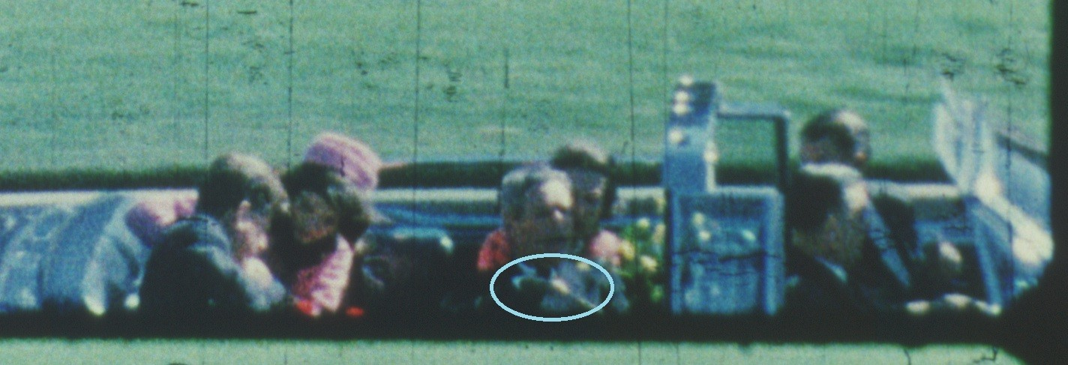

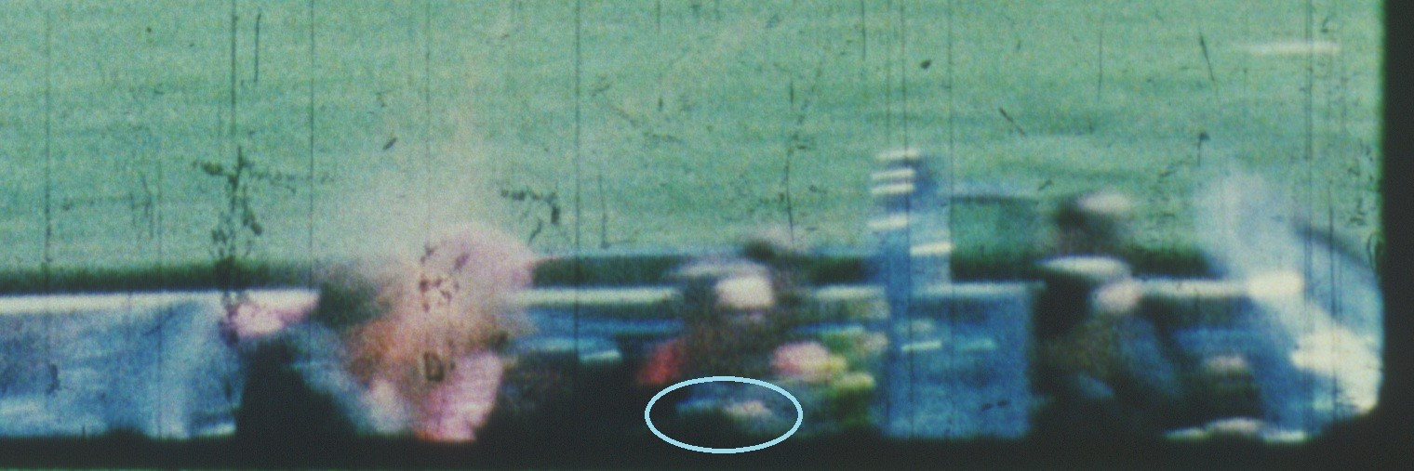
Figure 23 Frame 312

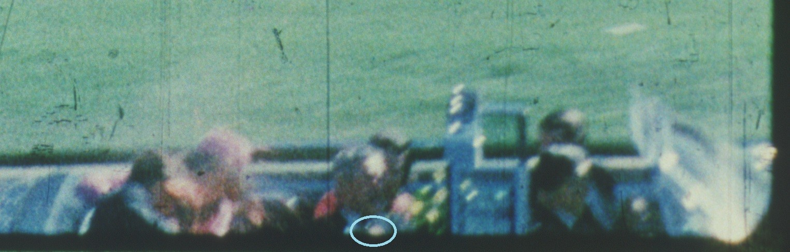
Figure 24 Frame 313

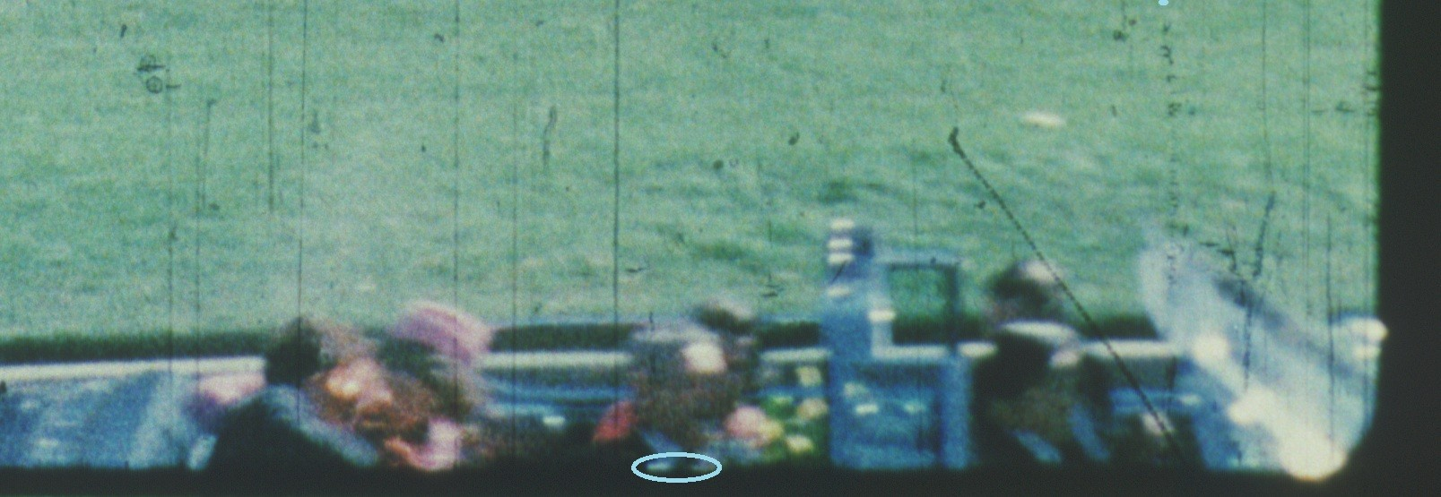
Figure 25 Frame 314
Figure 26 Frame 315

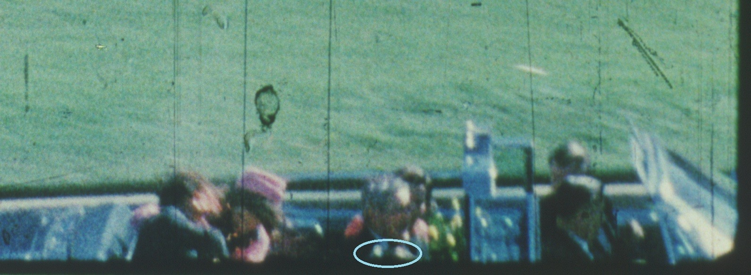
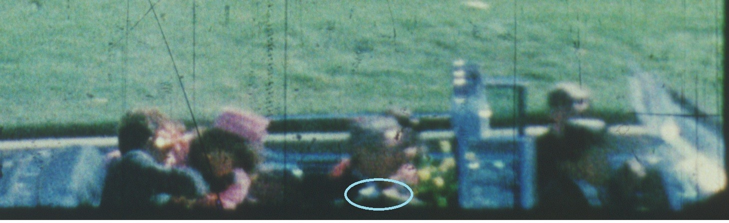
Figure 27 Frame 316
Figure 28 Frame 317
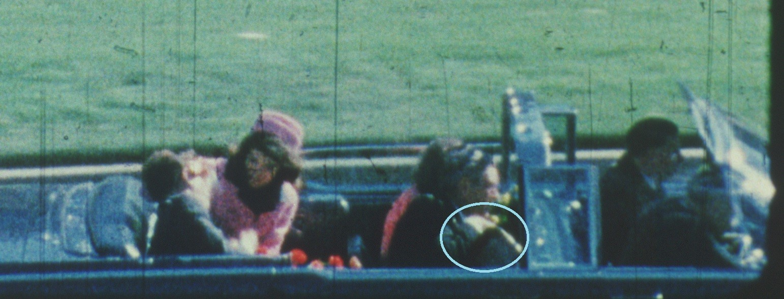
Figure 29 Frame 323

What seems remarkable in this series of frames is how static Connally’s right hand and wrist are in holding his white Stetson to his chest. What we can see of his hand, wrist and Stetson - from frame 312 through frame 317 - indicates that they stay fixed in the same position relative to Connally’s chest as he turns left in the limousine.
In frame 323, Connally has virtually completed his turn and is now facing forward in the limousine. Note that his hand and wrist are gripping his upside-down Stetson in the same position he has held it since frame 230. Having suffered a damaging blow to his wrist that shattered the radius bone at its widest point, we would expect this to show an inability to hold onto his Stetson. And, by Robertson, such a collision of a bullet fragment with his wrist ought to drive his wrist towards the front of the limousine. We see neither of these effects.

As with Robertson’s mistake with the two photos, once again this mistake is a major WHOOPS! Instead of advancing his claim, by drawing attention to the static position of his right hand and wrist relative to his chest after frame 313, Robertson has once again destroyed his own contention.

Robertson continues to argue that two shots hit the President’s head between frames

312-315, and that the shot fired at 328 missed. Where did it go? Robertson claims

that it struck a chrome strip rear-facing just above the windshield. The impact point is

shown in the photo below:
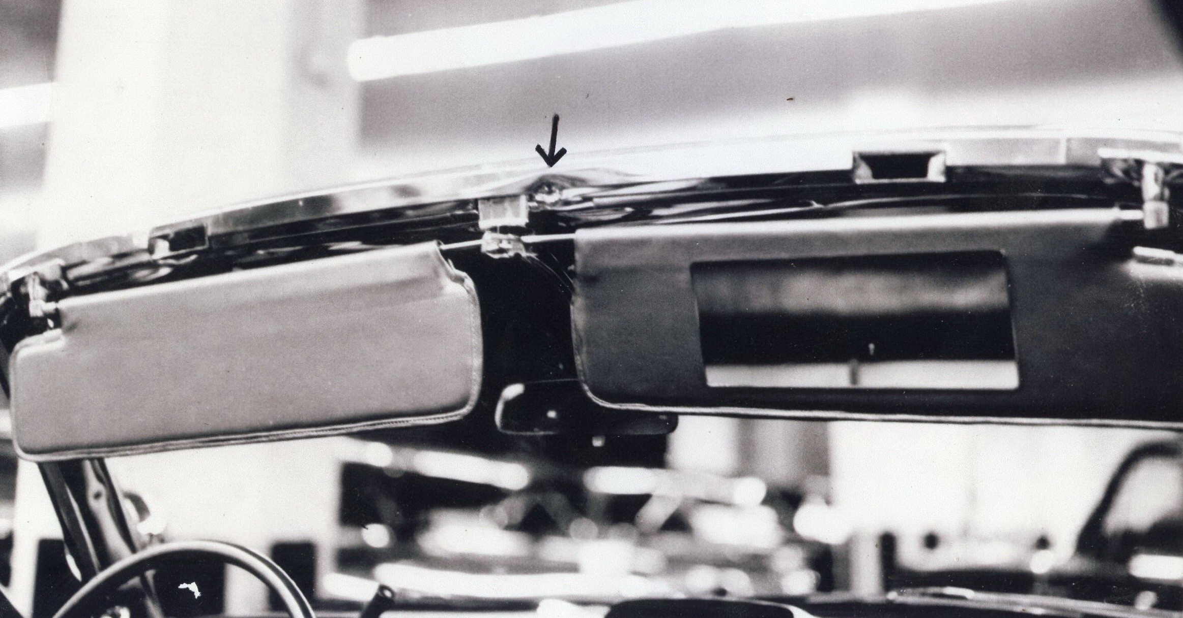
Figure 30 Commission Exhibit 349
On page 12, Robertson almost buries his controversial claim that “a whole bullet directly struck the windshield at frame 328 bending its tip in the process and falling back into the limo where it was later discovered during the initial limo inspection.”
This “whole bullet” is never mentioned in the notes FBI Agent Robert Frazier kept during his forensic examination of the limousine at the Secret Service garage between 2:00 AM and 4:30 AM on the morning of November 23rd.
Frazier was questioned extensively by the Warren Commission concerning his examination of the limousine and nowhere in his testimony is there any mention of any complete projectile being found or brought to his attention.
In fact, when questioned by Allen Dulles about the impact on the chrome strip shown above, Agent Frazier is quite insistent that it could not have been made by a complete bullet:

Mr. Dulles. I wonder if I could go back just a moment to the indentation in the chrome around the windshield at the top of the windshield, but on the inside, could that have been caused by a fragment of a bullet?
Mr. Frazier. Yes. It very easily could have. It would not have been caused, for instance, by a bullet which was traveling at its full velocity from a rifle, but from a fragment traveling at fairly high velocity which struck the inside surface of the chrome.

Dulles asks if the dent could have been caused “by any of the fragments that you have identified as having been found on the front seat or near the front seat of the car?” Frazier replied:

Mr. Frazier. Yes; I believe it could have been either, in fact, of the two fragments of rifle bullets found in the front seat.

Commission Counsel Arlen Specter then asked Frazier what would have been the effect on the chrome strip had a “whole bullet” projectile exited the President’s throat at a velocity between 1,772 and 1,798 feet per second and gone on to strike the chrome strip. Frazier replied:

Mr. Frazier. It would have torn a hole in the chrome, penetrated the framing both inside and outside the car. I can only assume, since I haven’t tested the metal of that particular car. I would assume that the bullet would completely penetrate both the chrome, the metal supporting the chrome, on the inside, and the body metal on the outside which supports the windshield of the car. [For all Frazier quotes, 5H70-71]

Frazier’s description of the damage to the chrome strip caused by a whole rifle bullet ripping through and tearing open both the chrome strip and its steel supports also has consequences for the condition of any whole rifle bullet after such a collision. Could it possibly have remained whole after such a violent collision?

The other bullet fragment found in the front seat area is shown in figure 31. The simplest explanation is clearly that CE 567 dropped down into the front seat area after striking the windshield at 328/329. CE 569 likewise dropped into the front seat area at 328/329 after striking the rear-facing chrome strip shown in Figure 30.
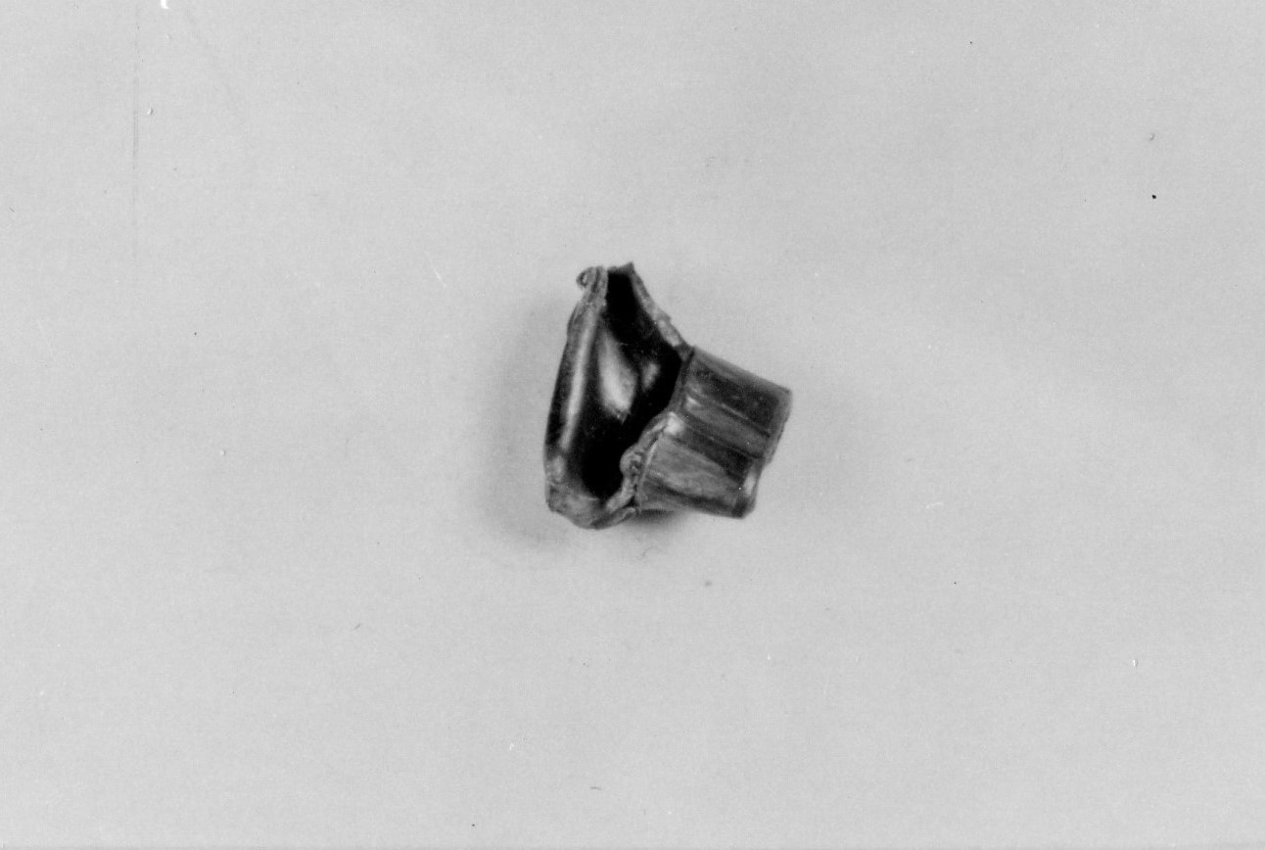

Figure 31. Commission Exhibit 569 found in the front seat of the limo along with CE 567.

*************************

White House Physician James Young and “the whole bullet” allegedly found in the Limousine

Due to Robertson’s insistence that two bullets—one from the rear, the other from the right front—struck Kennedy in the head between frames 312 and 315, by the time he gets to frame 328 he has run out of shots that could have hit Kennedy. Because the acoustics evidence places a final shot at frame 328, Robertson honors the existence of the shot but turns it into a miss. Robertson claims this shot’s projectile impacted pristinely on the chrome strip over the windshield. The evidence for this is extraordinarily thin. He writes on page 12 of his review:

A whole bullet directly struck the windshield frame at 328 bending its tip in the process and falling back into the limo where it was later recovered during the initial limo inspection. The non- fragmented bullet with a bent tip was chronicled by autopsy attendee and WH physician James Young, MD in his 2001 US Navy BUMED Oral History interview as well as in a confidential letter sent to ex-Warren Commission member and ex-President Gerald Ford. The existence of this whole bullet is also antithetical to a bullet fragmenting after a rear impact at 328.

Dr. Young was an assistant White House physician at the time and had not accompanied the President on his trip to Texas. When the Presidential party arrived in Washington, Dr. Young went out to Bethesda to offer what help he could to his boss, Rear Admiral George Burkley.

At Bethesda, he was joined by two Chief Petty Officers from the White House Medical Office—Chief Thomas Mills and Chief William Martinelli. According to Young, after being in the autopsy room for “three to four hours” Commander Humes said “that he was missing some bones from the President’s skull and he wondered whether there might be some pieces left in the back of the ‘Queen Mary’ [the Presidential limousine] and that he would like to get those pieces and bring them back to Bethesda so he could reconstruct the head.”

Chiefs Mills and Martinelli responded to Cdr. Humes’ request and returned from the car with an envelope. Young said, “The envelope contained three pieces of skull bone, one about three inches in diameter. It also contained a brass slug about half a centimeter in diameter and distorted. These were found on the floor of the blood-spattered convertible. The convertible was splattered with considerable brain tissue.”

After doing the Oral History interview, Young wrote to President Gerald Ford asking Ford if he knew anything about the “brass slug” Chiefs Mills and Martinelli had found in the limo. Ford replied, “No, he didn’t know anything about it, had not heard anything about it ever.”

Young contacted Senator Arlen Specter but learned nothing further. By 2001, Chief Martinelli had died but Chief Mills had retired to Johnson City, Texas. Young said: “I picked up the phone and I called him. He confirmed exactly what I had put down in my notes, that there was a bent brass slug that they had brought out that they had picked up off the floor of the Queen Mary.”

This is all Robertson says about Dr. Young and the “bent brass slug” that Chief Mills or Marinelli found on the floor of the Presidential limousine. This is odd since one of the most foundational documents in the case—Commission Document 80, a 15-page document including photos and another SS Report—tells in granular detail how the various fragments were discovered on the evening of November 22nd.

This Report, moreover, is foundational in the case because it charts the discovery of two limousine bullet fragments that were later found to have been fired from the rifle found on the 6th floor of the Depository. On the Mary Ferrell site it is described as “Commission Document 80 - Secret Service Report of 06 Jan. 1964 re: Presidential car.”* Below is a photocopy of a paragraph from page 2 of the Report:
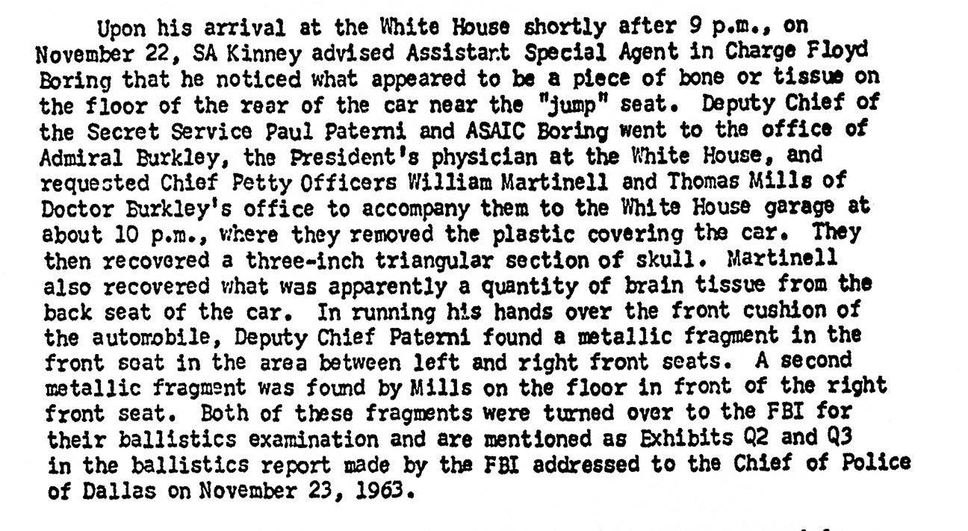
Figure 32 Paragraph from page 2 of Commission Document 80

Q 2 and Q3 were delivered to the FBI Laboratory on the evening of November 22, 1963. In a November 23, 1963 FBI Report to Chief Jesse Curry of the Dallas Police, they were described as follows:

Q2 Bullet fragment from front seat cushion
Q3 Bullet fragment from beside front seat

On page 3 of the same report, the description continues:

Specimen Q2 is a portion of the core of a rifle bullet.
Specimen Q2 weighs 44.6 grains and is composed of a portion of the lead core. Specimen Q 3 is a portion of the base section of a copper alloy rifle bullet. Q3 weighs 21.0 grains and is composed of a section of the jacket from which the lead core is missing. It could not be determined whether specimens Q2 and Q3 are portions of the same bullet or are portions of two separate bullets.

The rifle, K1, is a 6.5-millimeter Mannlicher -Carcano Italian military rifle Model 91/38. Test bullets were fired from this rifle for comparison with specimens Q1 [later CE 399], Q2 [later CE 567] and Q3 [later CE 569]. As a result, Q1, Q2 and Q3 were identified as having been fired from the submitted rifle.

Shown below is a National Archives photo of Q3 [later C3 and still later CE 569].
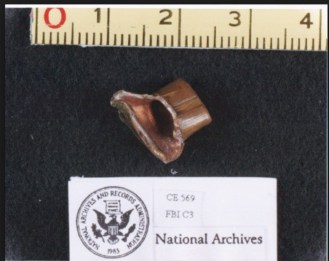

Figure 33 – Another view of Commission Exhibit 569 – not a whole bullet
Dr. Young said the envelope containing three skull fragments “also contained a brass slug about half a centimeter in diameter and distorted.” The diameter of CE 569 is, of course, “about half a centimeter in diameter” at exactly 6.5 millimeters. It is made up of only copper jacket material and therefore might easily appear to be “brass.”** One end of it is obviously “distorted,” as in the description Dr. Young provided. Dr. Young used the term the term “slug” to describe it and it is on this term that Robertson builds his case that a “whole bullet” was found in the limousine.

The Columbia Dictionary of the English Language (2nd Edition Unabridged) lists 17 different meanings for “slug” of which two might conceivably apply to CE 569. Meaning #4 defines “slug” as “a piece of lead or other metal for firing from a gun.” Meaning #5 defines “slug” as “any heavy piece of crude metal.” Meaning #4 might conceivably apply to a whole projectile while Meaning #5 would more likely apply to a substantial fragment.

Now with the whole story of what happened in the White House garage fully described in various reports, whatever Dr. Young thought he was seeing is rendered irrelevant. We know what happened. It was not just Martinelli and Mills who searched the limousine. They were given permission to search the limousine by Deputy Chief of the Secret Service Paul Paterni who then accompanied them along with Assistant SAIC Floyd Boring. Chief Thomas Mills found Q3 “on the floor in front of the right front seat.” Q3, along with Q2, were sent along to the FBI Laboratory and, as we saw, are mentioned in an FBI Report to Chief of Police Jesse Curry of Dallas on November 23, 1963.***

No “non-fragmented bullet with a bent tip” ever existed. Robertson made up its

existence out of an ambiguity in Young’s use of the term “slug.” No “complete bullet” was ever found in the limousine. Dr. Young was referring to Q3, later designated C3, and even later designated CE 569.

- Robertson insists that two shots were fired virtually simultaneously between
Z frames 312 and 315. However, the acoustics evidence shows only one shot at this time--from the right front.

With the return of the acoustic evidence to legitimacy, it is difficult to understand or come to terms with Robertson’s position. At various points he seems to agree with the arguments in Last Second that the acoustic evidence is quite valid. On the other hand, the acoustic evidence remains unshakable on the point of there being one and only one sound impulse of a shot on the tape between 312/313 and a later shot at 327/328. There is no double shot at 312-315. The oscillograph photo below shows this point with indelible clarity:
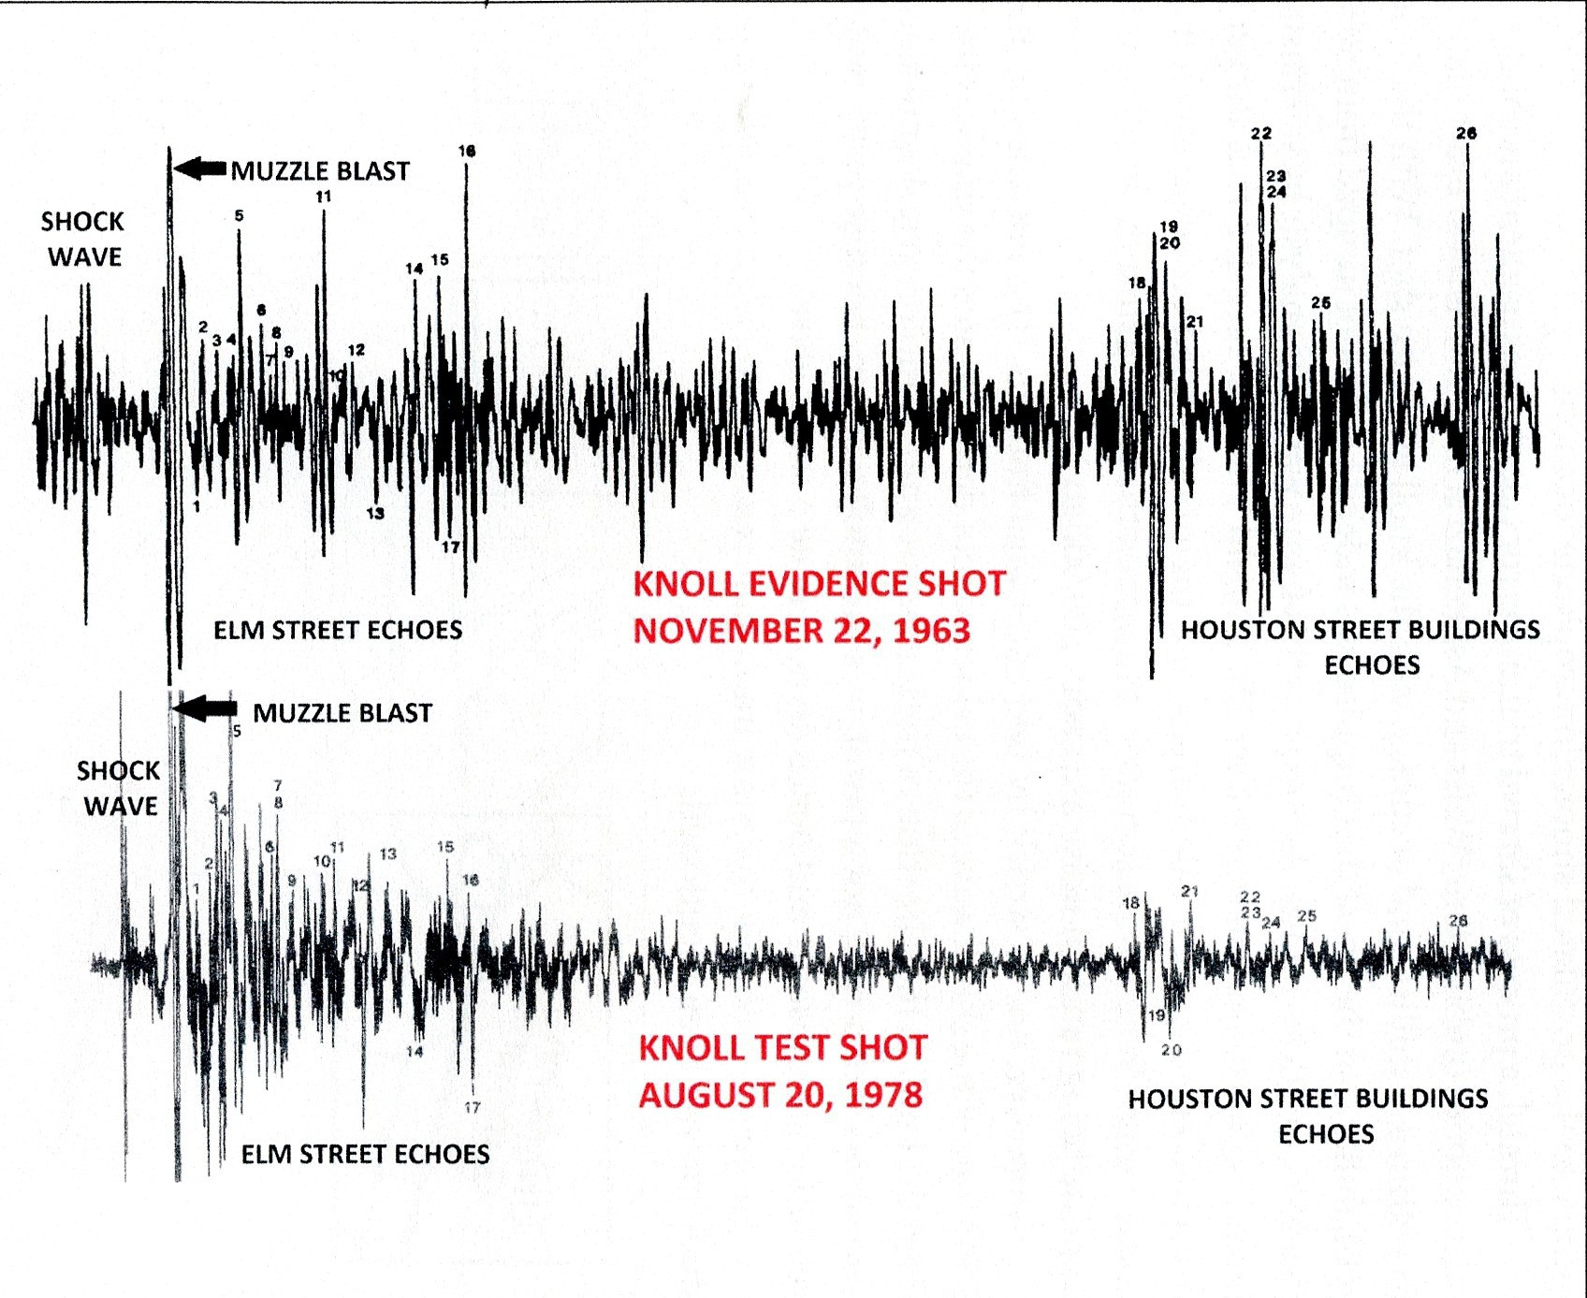
Figure 34 Comparison of shock wave, muzzle blast and appearance of 26 echoes between the 11/22/63 knoll shot and the 8/20/78 test shot.
One shot was fired from behind the fence on the knoll on August 20, 1978 and it matched the next-to-last shot fired on November 22, 1963. Above is shown a match between two individual shots fired fifteen years apart in the same Plaza.
According to the acoustic experts, after the knoll shot that struck JFK at Z frame 313 on November 22nd, the next shot comes 0.75 seconds later at frames 327-8, and does all the damage described in Chapter 15 of Last Second in Dallas.
Weiss and Aschkenasy were able to match all 26 echo reflections to 26 echo reflecting points in Dealey Plaza. How can Robertson see the acoustic evidence as valid yet maintain two shots between 312 and 315?

*To view Commission Document 80 enter expanded search in Mary Ferrell site with “Commission Document 80 – Secret Service Report of 06 Jan.1964 re: Presidential car.”

**For Dr. James Young’s oral history and his contact with President Ford and Chief Mills see: https://aarclibrary.org Then, scroll down and click on “Navy Medicine and President Kennedy’s Autopsy: Recollections from a former White House Physician.”

***For FBI Laboratory Report to Dallas Police Jesse Curry see: https://texashistory.unt.edu/ark:
/67531/metapth339265/m1/9/.

